Address: ______________________________________ City, State, Zip: _____________________________________
Phone Number (Home): _________________________ Phone Number (Cell): ________________________________
Preferred Method of Contact: ____________________ Can the office leave a message? YES / NO

Emergency Contact:

Name: _____________________________________ Relationship: ______________________________________

Phone Number (Home): _______________________ Phone Number (Cell): ______________________________

Medical Contacts:

Name of Medical Doctor / Family Physician: __________________________________________________________
Address: ________________________________________________________ Telephone: _____ - _____ - _____
Please list any other health care providers (name, specialty, telephone): __________________________________
______________________________________________________________________________________________
Insurance Information:
Payment / Copay Options: ☐Cash ☐Check ☐Credit/Debit Card SS# ____________________________
Insurance Co: _________________________________________ Phone: ____________________________________
Address: _____________________________ City: _______________________ State/Zip:_______________________
ID#:________________________________________________Group#:______________________________________
Insured Name: ☐Self ☐Other______________________________ Insured Phone: (_____)_________________
Insured Address:____________________________ City: _____________________State/Zip:____________________
Insured SSN:_______________________________ Insured DOB: _____/______/________
Relationship to Insured:______________________ Insured ☐ M ☐ F
Insured Employer & Address:_______________________________________________________________________
MEDICAL HISTORY

Please list your health concerns in order of importance:
1. ________________________________________ 2. ____________________________________________
3. ________________________________________ 4. ____________________________________________

What has your doctor (currently and previously) diagnosed you with? _______________________________
_________________________________________________________________________________________

Please list known allergies (environmental, food and medications):_________________________________
_________________________________________________________________________________________

Please list any and all current medications (prescription and over-the counter) & supplements (vitamins, herbs):
Name of Drug/Supplement | Date Started | Dosage/Frequency | Prescribed for:
Please describe any major illnesses, hospitalizations, surgeries, imaging, etc. (include date of occurrence): _________________________________________________________________________________________
_________________________________________________________________________________________
_________________________________________________________________________________________
_________________________________________________________________________________________

Are you up to date on vaccinations? (circle one) YES / NO
Do you smoke cigarettes? ______ If yes, how many per day and for how long? ________________________
Do you use recreational drugs? ______ If yes, what and how often? _________________________________
Do you consume alcohol? ______ If yes, what and how often? _____________________________________

DIET
Please write down what you had for each meal in the past 24 hours:
Breakfast: ___________________________________ Lunch: ______________________________________
Dinner: _____________________________________ Snacks / Dessert: ______________________________
Water (number of cups): ______________________ Cravings: ____________________________________
Do you exercise? If so, what and how often? ____________________________________________________
_________________________________________________________________________________________

SLEEP
Average hours of sleep per night: ______________ Do you wake feeling rested? YES / NO
Do you wake during the night, if so why? _______________________________________________________
Rate your energy on a scale of 1 (low) to 10 (high): ______________________
What time of day is your energy lowest? __________ What time of day is your energy highest? __________

WHEEL OF LIFE
Shade in each section to represent your fulfillment of that aspect of your life):

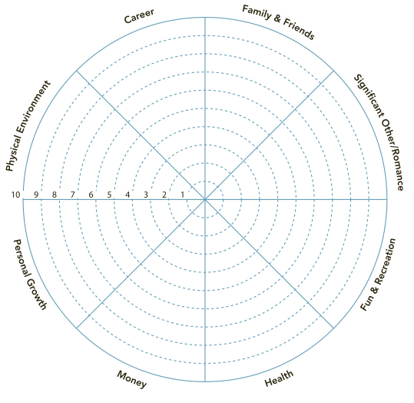

FAMILY HISTORY

 | Age at Death  (if living leave blank) | Health Conditions
Mother
Father
Siblings
Maternal Grandmother
Maternal Grandfather
Paternal Grandmother
Paternal Grandfather

REVIEW OF SYSTEMS (check all that apply)

GENERAL  ☐Chills  ☐Fever  ☐Dizziness/vertigo  ☐Light-headedness  ☐Forgetfulness  ☐Fatigue  ☐Hair loss  ☐Headache  ☐Nervousness  ☐Anxiety/depression  ☐Sweating  ☐Numbness  ☐Loss of sleep  ☐Weight loss or gain  SKIN  ☐Easy bruising  ☐Hives/itching  ☐Moles  ☐Rash  ☐Scars/keloids  ☐Sores/ulcers  GENITO-URINARY  ☐Painful urination  ☐Frequent urination  ☐Lack of bladder control  ☐Change in urine odor  ☐Frequent UTI  ☐Blood in urine | CARDIOVASCULAR  ☐Arrhythmia/murmur  ☐Atherosclerosis  ☐Chest pain  ☐Palpitations  ☐Shortness of breath  ☐High blood pressure  ☐Low blood pressure  ☐Cold extremities  ☐Swelling in hands/feet  ☐Varicose veins  Other:_____________________  GASTROINTESTINAL  ☐Poor appetite  ☐Gas/Bloating/belching  ☐Foul odor in stool/gas  ☐Change in bowels  ☐Constipation  ☐Diarrhea  ☐Excessive thirst  ☐Excessive hunger  ☐Ingestion/heartburn  ☐Nausea/vomiting  ☐Hemorrhoids  ☐Stomach pain/discomfort  ☐Blood in stool  NEUROLOGIC  ☐Loss of coordination  ☐Seizures/epilepsy  ☐Fainting  ☐Paralysis/weakness  ☐Brain fog/memory difficulties | EYE/EAR/NOSE/THROAT  ☐Visual floaters  ☐Increased tearing or dryness  ☐Blurred/double vision  ☐Glaucoma/cataract  ☐Earache  ☐Ear discharge  ☐Ringing in the ears  ☐Hearing loss  ☐Stuffy or runny nose  ☐Nosebleeds  ☐Sinus problems  ☐Teeth or gum problems  ☐Dry mouth  ☐Bleeding gums  ☐Hoarseness  ☐Bad breath  ☐Difficulty swallowing  ☐Persistent cough  ☐Tonsil removal  MEN ONLY  ☐Breast lumps  ☐Difficulty with erections  ☐Lump in testicles  ☐Sore penis  ☐Pain with intercourse  ☐Penile discharge  ☐Ejaculation problems  Other:_____________________  Dates of last:  Prostate exam _____________ | WOMEN ONLY  ☐Abnormal PAP smear  ☐Breast tissue changes  ☐Mid-cycle bleeding  ☐Painful menses  ☐Menstrual clotting  ☐Nipple discharge  ☐Vaginal discharge  ☐Vaginal dryness  ☐Vaginal pain  ☐Pain with intercourse  ☐Loss of libido  ☐Hot flashes  ☐Lack of menses  ☐PMS symptoms  ☐Infertility  Other:__________________  Dates of last:  Menstrual period __________  PAP smear _______________  Mammogram _____________  Thermogram _____________  Are you pregnant? _________  Total# of pregnancies ______  Number of children ________

Why did you choose to come to this office? _____________________________________________________
_________________________________________________________________________________________
What do you know about my approach? _______________________________________________________
_________________________________________________________________________________________
What three expectations do you have from this visit to our clinic? __________________________________
_________________________________________________________________________________________
What long term expectations do you have from working with our clinic? _____________________________
_________________________________________________________________________________________
What expectations do you have of me personally as your physician? ________________________________
_________________________________________________________________________________________
What is your present level of commitment to address any underlying causes of your signs and symptoms that relate lifestyle? (Rate from 1 to 10, 10 being 100% committed)
1 2 3 4 5 6 7 8 9 10

What behaviors or lifestyle habits do you currently engage in regularly that you believe support your health? (Please list) ________________________________________________________________________ _________________________________________________________________________________________
_________________________________________________________________________________________
What behaviors or lifestyle habits do you currently engage in that are detrimental to your health? (Please list) _____________________________________________________________________________________
_________________________________________________________________________________________
_________________________________________________________________________________________
What potential obstacles do you foresee in addressing the lifestyle factors which are undermining your health and in adhering to the therapeutic protocols which we will be sharing with you? ________________
_________________________________________________________________________________________
_________________________________________________________________________________________
Who do you know that will sincerely support you consistently with the beneficial lifestyle changes you will be making? _______________________________________________________________________________
_________________________________________________________________________________________
_________________________________________________________________________________________
What do you LOVE to do? ___________________________________________________________________
_________________________________________________________________________________________
_________________________________________________________________________________________

Thank you for taking the time to fill out this intake!

